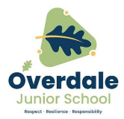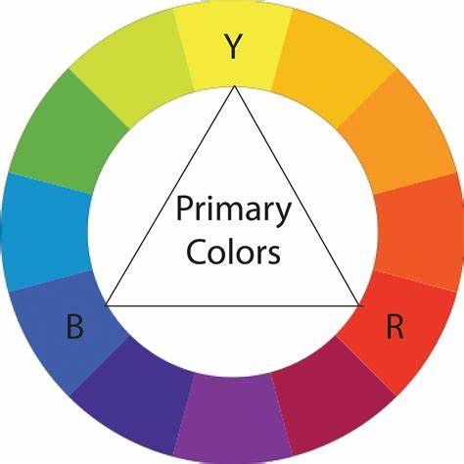

**Year 3 Art – All Work and No Play. Artist - L.S. Lowry**

**What should I already know?**

* A colour wheel can help us to mix colours.
* Some colour wheels have 12 colours:

3 primary, 3 secondary and 6 tertiary.

* It also shows warm and cool colours.
* Techniques which involve colour mixing are tint,

shade and tone.

|  |  |  |  |
| --- | --- | --- | --- |
| stippling | hatching | cross  hatching | circulism |

**Key Vocabulary and definitions**

|  |  |
| --- | --- |
| **Genre art** | Art showing things or scenes from everyday life |
| **Industrial** | factories, places or things to do with business and making things with machines |
| **urban** | a town or city |
| **background** | the scene or setting in a picture |
| **foreground** | the main focus or front part of a picture |
| **technique** | skills or ways of doing things |
| **horizon** | the imaginary line where sky and land meet |
| **composition** | how things and shapes are put together to make an image |
| **background wash** | painting a see-through block of colour to make a background |
| **sketch** | a rough or unfinished drawing or painting |
| **tone** | how light or dark a colour is |

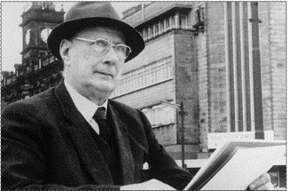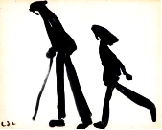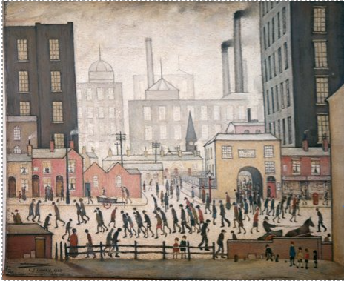

**About the artist**

* **Laurence Stephen Lowry** is a famous English artist.
* He was born on **1st November 1887** in Stretford, Lancashire. ​
* Lowry family moved to the industrial town of **Pendlebury** in 1909.
* Lowry’s paintings often showed scenes of **urban industrial life** in Pendlebury.
* His painted people as stylised ‘**matchstick men**’ figures.

‘Coming from the Mill’ - by Lowry

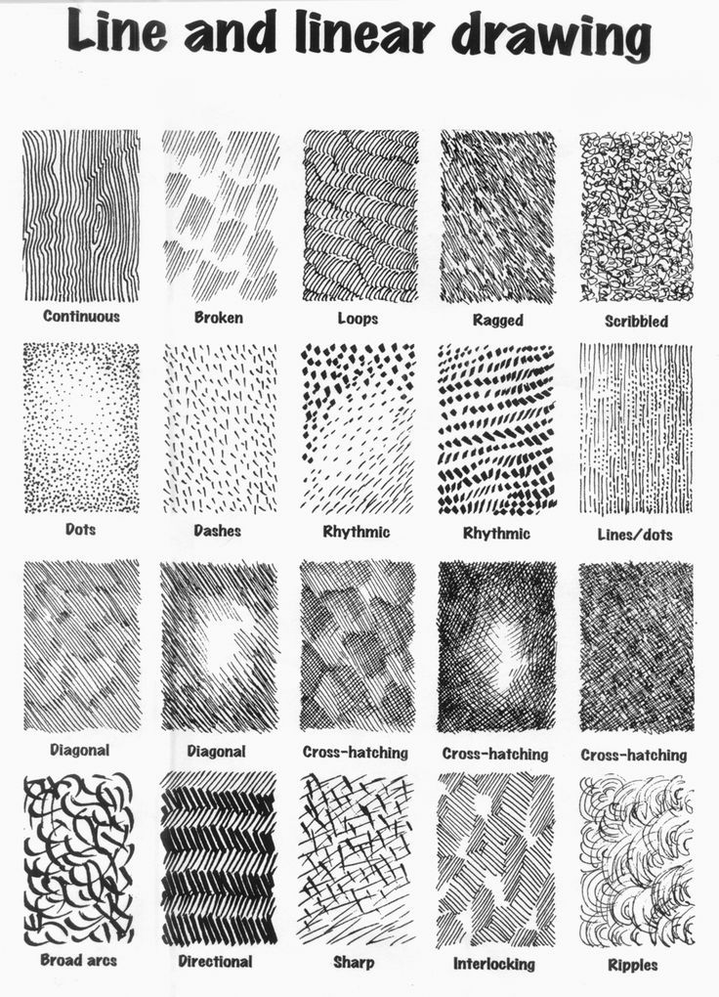

**Lowry and Colour**

Ivory black Vermillion Prussian blue Yellow ochre Flake white

Different mark making techniques.  
To make lighter and darker tones.