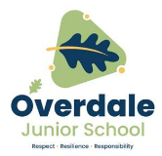

**Year 3 Art – Ghanaian Folk Art. Artist: Contemporary West African Artists**

**What should I already know?**

* Some colour wheels have 12 colours:

1. primary, 3 secondary and 6 tertiary.

* Artists are influenced by the places where they are from.
* Composition means how shapes are put together to make an image.
* Techniques are skills or ways of doing things.

**Key Vocabulary and definitions**

|  |  |
| --- | --- |
| **Cultural tradition** | Things that are done in a place where you are from. |
| **custom** | Things that have been done for a long time. |
| **Folk Art** | Art made by craftsmen and people who had no formal training. |
| **Ghanaian** | Coming from the African country of Ghana. |
| **pattern** | A design made by repeating shapes or lines. |
| **Kente cloth** | Special Ghanaian cloth woven from silk and cotton. |
| **weaving** | The process of making something by creating a pattern of over and under. |
| **loom** | Frame used to weave cloth. |
| **warp** | Lines of thread that are held in tight parallel lines. |
| **weft** | The thread that is woven over and under the warp. |

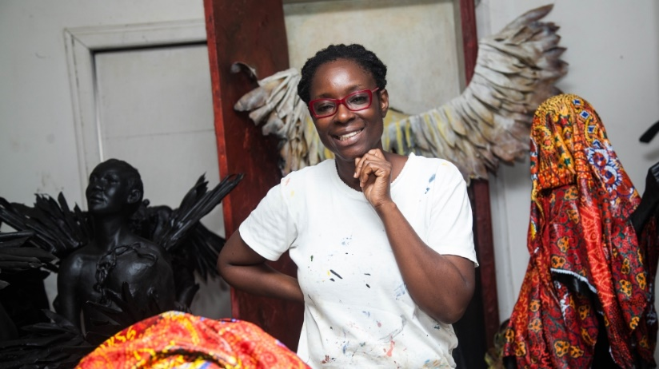

**About the artist**

* Peju Alatise was born in Nigeria in 1975.
* She makes sculptures out of many different

objects and materials including beads, cloth,

wood and plastic.

* She uses much of her work to make statements

about women’s rights.

* Her artwork is influenced by Nigerian and Yoruba culture and myths.
* Kente cloth is made up of different colours, patterns and shapes.
* Once, only members of the royal family of the Ashanti kingdom were allowed to wear it.

**Kente Colours**

The colours in Kente cloth have special meanings in Ghana.

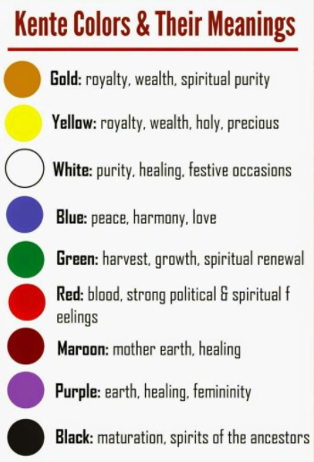 

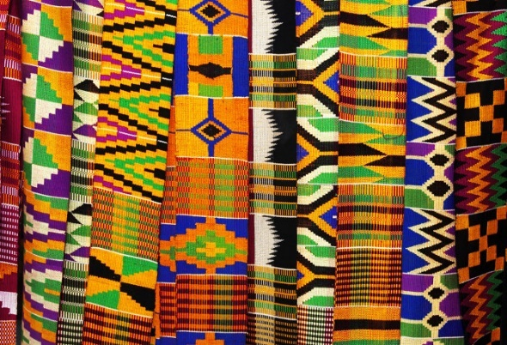 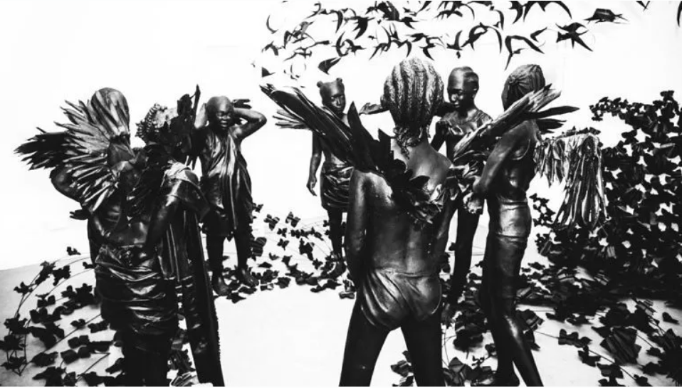

An example of Kente cloth

Flying Girls by Peju Alitise