

**Year 3 Art – Abstract Art. Artist: Wassily Kandinsky**

**What should I already know?**

* A colour wheel can help us mix colours.
* Some colour wheel contains 12 colours: 3 primary, 3 secondary and 6 tertiary. It also shows warm and cool colours.
* Line can be used to create shapes that can be
* filled in with colour.

**Key Vocabulary and definitions**

|  |  |
| --- | --- |
| **abstract** | Things that you can’t see or touch: e.g. ideas, happiness. |
| **Abstract Art** | Art that tries to show things that you can’t see. |
| **form** | Shapes |
| **collage** | Making art by gluing things to make an image. |
| **influence** | Have an effect on / get idea from |
| **Impressionist Art** | Art that tries to show the feeling of places and objects rather than just what they look like. |
| **synaesthesia** | One sense being set off by another – e.g. seeing a colour when you hear a sound. |

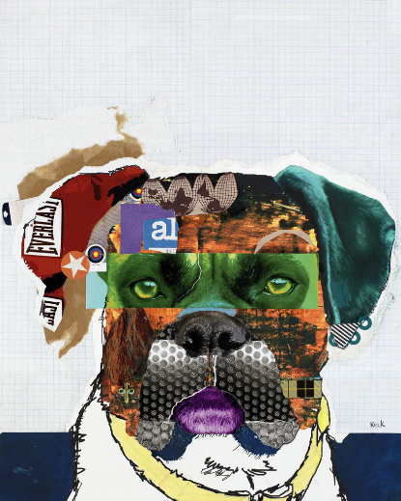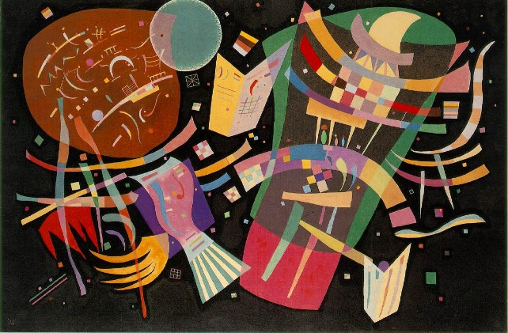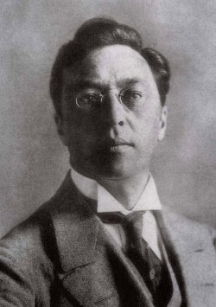

Composition IX - by Kandinsky

An example of collage using layers cut from magazines.

**Kandinsky and colour**

Kandinsky felt that colours matched different types of sounds.

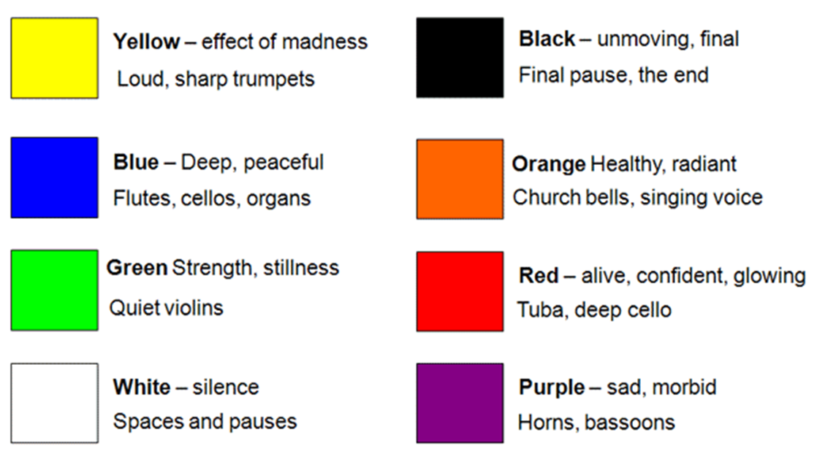

**About the artist**

* The artist Wassily Kandinsky was born in Moscow,

Russia on 4th December 1866.

* He became famous as one of the first painters of Abstract Art.
* As a young man he studied law and did not study painting until he was already 30.
* His work developed over time, influenced by Monet and Matisse - becoming more abstract.
* He used shape and colour to show feelings and emotions.
* He had Synaesthesia – so when he heard sounds he saw colour.
* Colour represented musical notes to him.