

**Year 3 French –Autumn 1- What is French and how can we use it in our classroom?**

**Grammar**

Some letters in French sometimes have symbols (called accents) above them which change the sound of the letter.

é à

**What should I already know?**

* France is a country in Europe.
* France is located close to the United Kingdom.
* The United Kingdom and France are separated   
  by the English Channel.
* French is the main language spoken in   
  France.

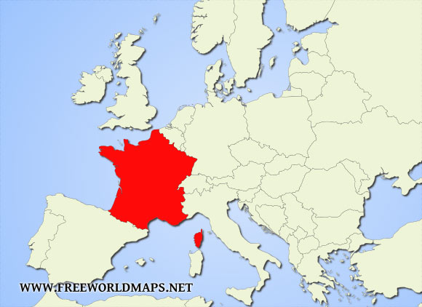

France

United Kingdom

English Channel

**Key French vocabulary (English translation)**

|  |  |
| --- | --- |
| **Les nombres - numbers** | |
| **1** | un |
| **2** | deux |
| **3** | trois |
| **4** | quatre |
| **5** | cinq |
| **6** | six |
| **7** | sept |
| **8** | huit |
| **9** | neuf |
| **10** | dix |

**Reading and listening:** I recognise these words when I see or hear them.

**Speaking**: I can pronounce the main sounds in the word.

**Writing**: I can copy the word down.

|  |  |
| --- | --- |
| **Les salutations - greetings** | |
| bonjour | hello |
| salut | hi |
| au revoir | goodbye |
| bon nuit | good night |

Practise your greetings at home: <https://www.bbc.co.uk/teach/supermovers/ks1--ks2-mfl-french-greetings-with-ben-shires/zdpdvk7>

Practise your numbers at home:

<https://www.youtube.com/watch?v=woqBQG7LG8s>

**Speaking and listening**

Some letters and sounds are pronounced differently to French. That means they sound differently when we speak and hear them.

“oi” in French makes the “wa”sound.

“ez” in French makes the “ay” sound.

|  |  |
| --- | --- |
| **Louer – praise** | |
| très bien | very good |

|  |  |
| --- | --- |
| **Règles de class – classroom instructions** | |
| écoutez | listen |
| regardez | look |
| asseyez-vous | sit down |
| levez-vous | stand up |
| répétez | repeat |
| silence! | quiet! |