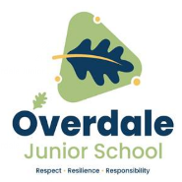

**Key French vocabulary (English translation)**

|  |  |
| --- | --- |
| **Fruit** | |
| **Une orange** | An orange |
| **Une poire** | A pear |
| **Les fraises** | Strawberries |
| **Une pomme** | An apple |
| **Les tomates** | Tomatoes |
| **Une banana** | A banana |
| **Un ananas** | A pineapple |

**Speaking and listening**

Some letters and sounds are pronounced differently to French. That means they sound differently when we speak and hear them.

“oi” in French makes the “wa”sound.

“ez” in French makes the “ay” sound.

**Grammar**

Some letters in French sometimes have symbols (called accents) above them which change the sound of the letter.

é à

**Year 3 French – Autumn 2 – Fruits and Opinions**

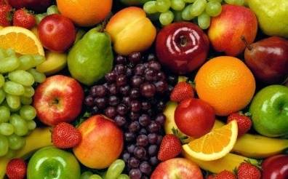

|  |  |
| --- | --- |
| **Opinions** | |
| J’adore | I love |
| J’aime | I like |
| Je n’aime pas | I dislike |
| Je déteste | I hate |

**Reading and listening:** I recognise these words when I see or hear them.

**Speaking**: I can pronounce the main sounds in the word.

**Writing**: I can copy the word down.

|  |  |
| --- | --- |
| **Louer – praise** | |
| très bien | very good |
| excellent | Excellent |
| super | super |

|  |  |
| --- | --- |
| **Les salutations - greetings** | |
| bonjour | hello |
| salut | hi |
| au revoir | goodbye |
| ça va | how are you? |
| très bien | very well |
| comme ci comme ça | so so |
| mal | bad |

**What should I already know?**

* Basic classroom instructions
* Numbers 1 – 10
* Greetings in French
* How to respond to and ask questions about how you are