

**Year 4: Art and Design – Identity: *Portraiture and Cubism.* Artist/Artisan: *Pablo Picasso***

**What should I already know?**

* How to create light and dark tones using stippling, hatching, cross-hatching and circulism *(Links back to Lowry work Y3)*
* That Wassily Kandinsky was an abstract artist.

**Key Vocabulary and definitions**

|  |  |
| --- | --- |
| portrait | A painting, drawing, photograph or engraving of a person. |
| self-portrait | A painting or drawing of yourself that is done by you. |
| subject | The main idea of the artwork. What is being shown. |
| realistic | True to life. |
| emotion | A strong feeling. |
| line | One of the seven elements of art. Everything begins with a dot and transforms into a line (straight, curved) and then into a drawing. |
| tone | Light or dark shades. |
| highlight | The brightest part of the artwork. |
| shading | Adding black to a colour to darken it down. |
| shadow | The dark side of an object, not facing the light. |
| proportion | Height, width and depth of an object. Affects how realistic a picture is. |
| cubism | A style of painting developed in the 1900s. The art shows objects from many angles all at once. It was not based on realistic views of subjects. |
| collage | An art technique using different materials (paper, photos, fabric) are arranged and stuck down to create a piece of artwork. |

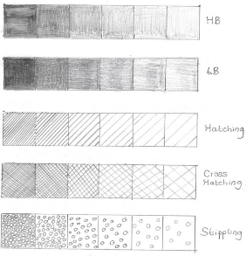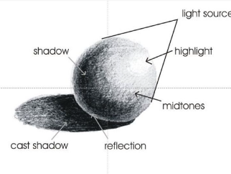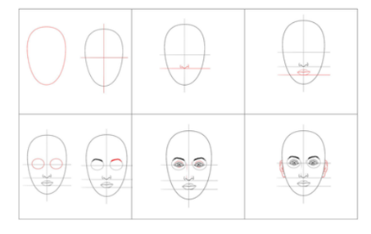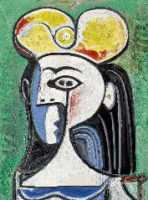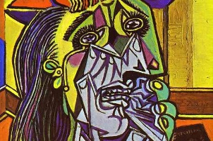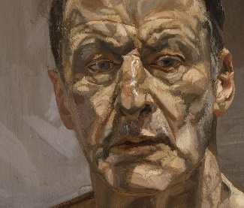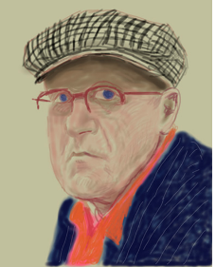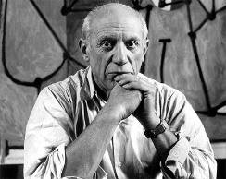

Drawing a Portrait

Creating Shadow

Creating Tone

Double Portrait by Picasso

**About the artist**

* Pablo Picasso was born in Spain in 1881.
* Father was a painter and art teacher.
* Loved to draw and his talents were

noticed by the age of 8.

* Was brilliant at drawing, loved colour and doodling.
* Went to art school, but didn’t want to paint like everyone else.
* From 1901-1904 painted in blue as it was a sad time in his life.
* From 1904-1906 painted using warm colours as he fell in love.
* In 1907 he began to experiment with a new style of painting where subjects were broken up into different sections and put back together from different angles. He called this ***Cubism.***
* In 1912, he combined Cubism with collage.

Weeping Woman

By Pablo Picasso

Self-Portrait by Lucien Freud

Portrait by David Hockney