

**Year 4 Art – Gothic Art. Artist: Paulo Uccello**

**What should I already know?**

* A composition is how things and shapes are put together to make an image.
* Perspective is making things smaller to make

them look further away or 3D.

* Tone is how dark or light a colour is.

**Key Vocabulary and definitions**

|  |  |
| --- | --- |
| **Medieval** | A period in history that started with the fall of the Western Roman Empire in 476 CE and that lasted for the next 1000 years. |
| **Gothic Art** | A style of painting where realistic people and animals are used in a brightly colourful and decorative way. |
| **Religious Art** | Art made for or about a religion.  It can be used to decorate a place of worship. |
| **zoom in** | Look at and draw a close-up part of an image in detail. |
| **replicate** | To copy exactly. |
| **texture** | Using tone and shading to make a surface look smooth or bumpy. |
| **sculpture** | Making 3D forms, often out of clay, stone, wood or metal. |
| **scales** | The small, thin, overlapping plates protecting the skin of fish and reptiles. |

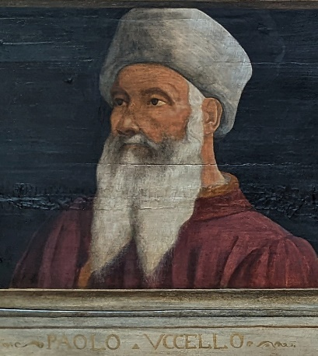

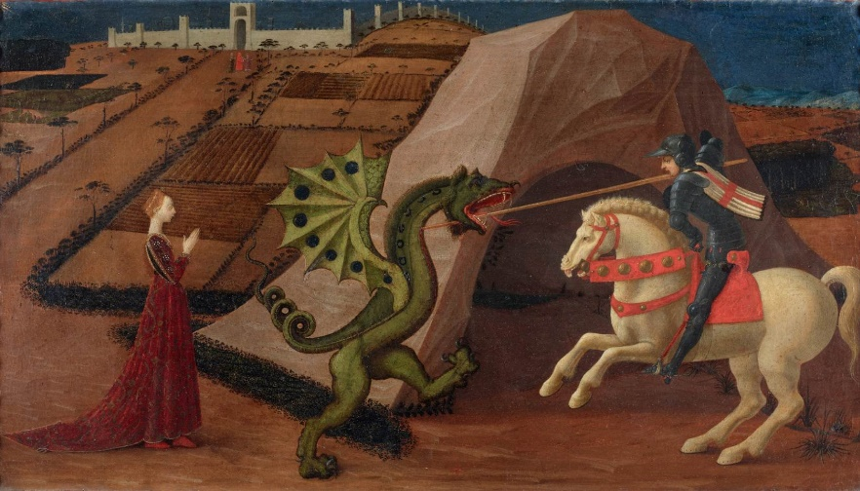.....

**Uccello’s colours**

Uccello used rich, deep colours that were realistic but also made his images look bright and decorative.

|  |  |  |  |
| --- | --- | --- | --- |
|  | green |  | brown |
|  |  |  |  |
|  | blue |  | grey |
|  |  |  |  |
|  | red |  | black |

**Saint George and the Dragon** - 1535

**Saint George and the Dragon** - 1570

**About the artist**

* Paolo Uccello was a famous medieval painter.
* He was born as Paolo di Dono in Italy in 1397.
* His nickname Uccello meant ‘little bird’ as he liked

painting birds.

* When he was 10 years old he was sent as an apprentice to work for and learn from the famous sculptor Lorenzo Ghiberti.
* He was one of the first artists to use perspective to show landscapes in a realistic and 3D way.
* He was an old man when he painted Saint George and the Dragon in 1470 and gave up painting soon after. He died in 1475.