

**Year 4 Art – Art Deco Art. Artist: Clarice Cliff**

**Key Vocabulary and definitions**

**What should I already know?**

* Abstract Art tries to show things that you can’t see.
* A pattern is a repeated design.
* Printing blocks can be used to repeat images.
* Art can be used to decorate objects.

|  |  |
| --- | --- |
| **Art Deco** | A style of decorative art, design and architecture of the 1920s and 1930s that used simple, clean stylised shapes. |
| **streamlined** | A shape that has been smoothed and simplified. |
| **geometric** | Decorated with regular lines and shapes. |
| **symmetry** | The same on both sides—a mirror image. |
| **repetition** | The same pattern or shape repeated. |
| **ceramics** | Pots, dishes and other things made from hardened clay. |
| **pottery** | Pots, dishes and other things made from hardened clay. |
| **printing** | A way of copying an image from a master copy. |
| **printing block** | A block that has a raised pattern on it for printing. |

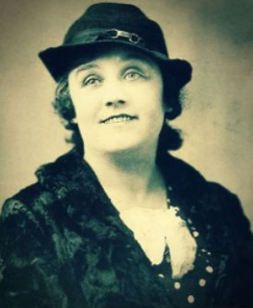......

**Clarice Cliff’s colours**

Cliff liked to use bright colours that give a feeling of Summer.

|  |  |  |  |
| --- | --- | --- | --- |
|  | orange |  | black |
|  |  |  |  |
|  | cream |  | blue |
|  |  |  |  |
|  | yellow |  | green |

Clarice Cliff ceramic designs

**About the artist**

* The ceramic artist and designer Clarice Cliff was

Born in Stoke-on-Trent in 1899.

* She studied art and sculpture and started working in the pottery industry at age 13.
* She used bright colours, strong black lines and simple geometric shapes to hand paint Art Deco designs onto pottery.
* They were very popular and sold in large numbers. Soon Clarice had 100 ceramic artists painting her designs.
* Some of her most famous ceramic collections were called ‘Bizarre’, ‘Crocus’ and ‘Fantastique’.
* Colour represented musical notes to him.