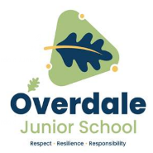

**Speaking and listening**

Some letters and sounds are pronounced differently to French. That means they sound differently when we speak and hear them.

“oi” in French makes the “wa”sound.

“ez” in French makes the “ay” sound.

**Grammar**

Masculine and feminine nouns

mon – masculine - my

ma – feminine – my

il – he ; elle - she

**Year 4 French – Summer – Clothing**

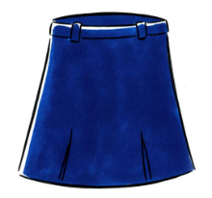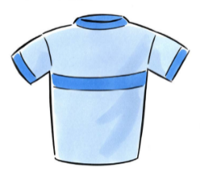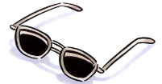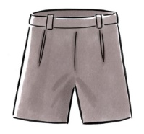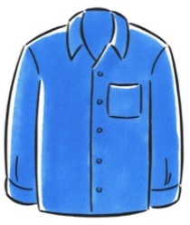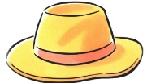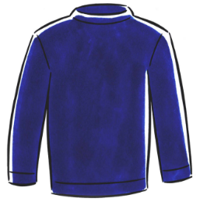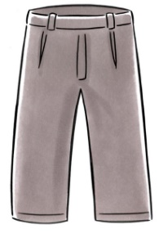

|  |  |
| --- | --- |
| **Key Vocabulary** | |
| un pantalon | trousers |
| un short | shorts |
| une jupe | a skirt |
| un pull | a jumper |
| un tee-shirt | a t-shirt |
| un chapeau | a hat |
| une chemise | a shirt |
| un maillot de bain | a swimsuit |
| des lunettes de soleil | sunglasses |
| Il fait chaud | It is hot |
| Il fait froid | It is cold |

|  |  |
| --- | --- |
| **Louer – praise** | |
| très bien | very good |
| excellent | excellent |
| super | super |

**Reading and listening:** I recognise these words when I see or hear them.

**Speaking**: I can pronounce the main sounds in the word.

**Writing**: I can copy the word down.

**Key French vocabulary (English translation)**

**What should I already know?**

* Basic classroom instructions
* Numbers 1 – 10
* Greetings in French
* Names of fruit in French
* Names of family members
* Colours
* Pets