

**Year 5 Art and Design – Pop Art. Artist/Artisan - Andy Warhol**

**What should I already know?**

* How to use a colour wheel, including some opposite (complementary) colours.
* Some knowledge about primary and secondary colours.

**Key Vocabulary and definitions**

|  |  |
| --- | --- |
| popular culture | Anything *‘popular’* from Coca Cola to pop stars to the clothes people like to wear. |
| pop art | Popular art that had a modern feel. |
| bold | Striking |
| bright | Vivid or stand out. |
| mundane | Dull, boring. |
| technique | Where you practise a skill and combine skills for effect. |
| screen printing | Creating a picture by pushing ink on to a surface through a screen. |
| silkscreen printing | A design is cut out of thin, strong material and printed by rubbing, rolling or spraying paint through cut out areas. |
| lithography | Printing from a metal plate or stone. |
| ben-day dots | https://upload.wikimedia.org/wikipedia/commons/thumb/1/11/Benday_Dots.svg/220px-Benday_Dots.svg.pngIs a printing and photoengraving technique dating from 1879.Is commonly described in terms of dots. Used in comics. |
| contrasting colours | Colours that are opposites on a colour wheel. |
| icons | People or objects seen as symbols of the latest trends. |

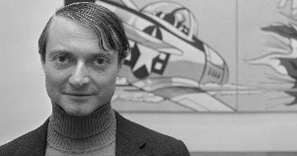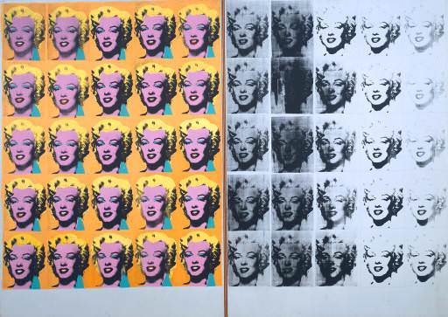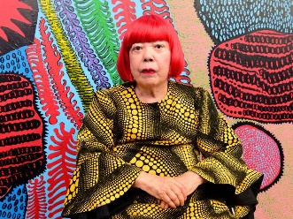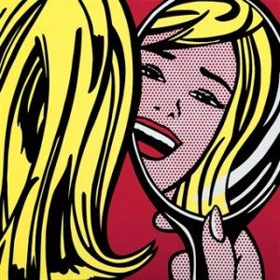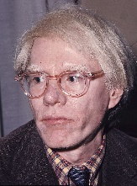

Marilyn Diptych by

Andy Warhol

Yayoi Kusama- Japanese pop artist

**Pop art**

Pop art is an art movement that started in the United Kingdom and the United States during the mid- to late-1950s.

Pop art was very different to classical, fine art and shocked many people at the time. It included imagery from popular and mass culture e.g. advertising, comic books and random objects such as cans of soup or washing powder.

Girl in Mirror by Roy Lichtenstein

**About the artist**

* Andy Warhol was part of the pop art movement.
* He was born Andrew Warhola in 1928 in Pennsylvania.
* His parents were from a place in Europe that is now part of Slovakia.
* They moved to New York in the 1920s.
* His first job was illustrating adverts in fashion magazines.
* Nowadays, he is known as one of the most influential artists who ever lived!