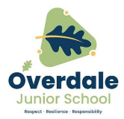

**Year 5 Art – Space Art. Artist: Robert McCall**

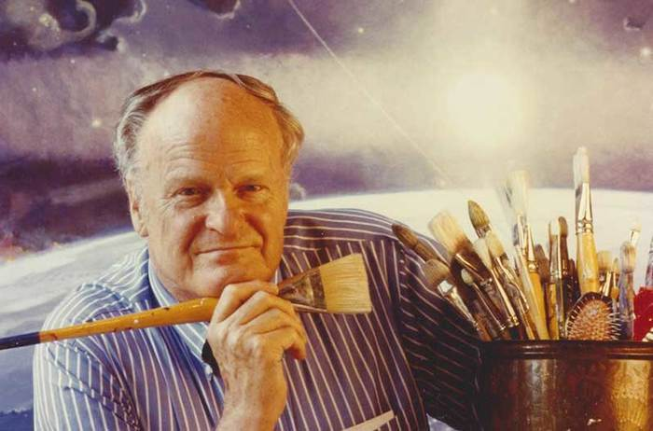

**Key Vocabulary and definitions**

**What should I already know?**

* A collage is made by putting layers

of different materials to make an image.

* Prints can be made using printing blocks

or found objects.

* Techniques which involve colour mixing

include tint, shade and tone.

|  |  |
| --- | --- |
| **Space Art** | A style of art that tries to show the wonders of the universe. |
| **astronomical** | Planets, stars and other objects in Space. |
| **NASA** | The American Space agency: National Aeronautics and Space Administration. |
| **Science Fiction** | Stories with made up science. |
| **collage** | Art made by gluing layers of different materials. |
| **layering** | Putting layers of paint, paper or any material on top of another layer to create an image. |
| **texture** | The feel or appearance of a material e.g. rough or smooth. |
| **focus point** | The main part that the viewer will look at. |
| **composition** | Putting the whole image together. |

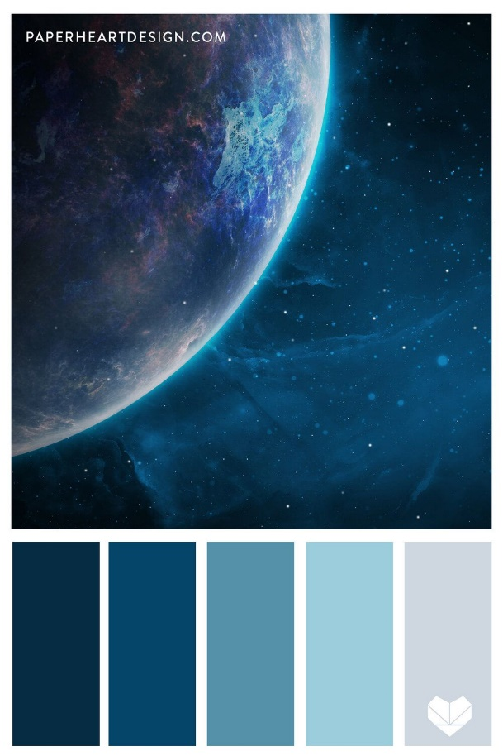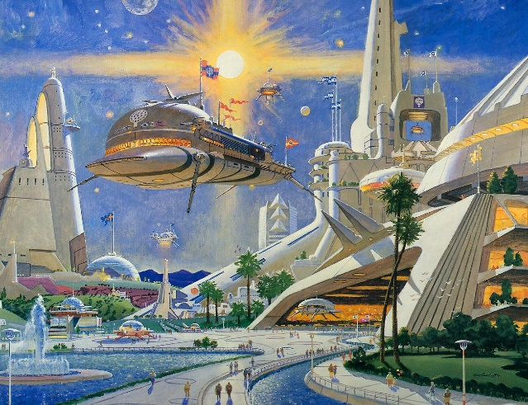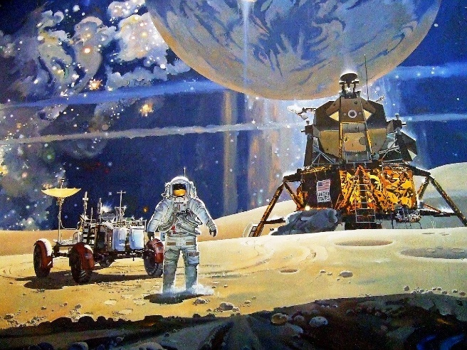 ......

Metropolis 2050 #3, 1984

The Space Mural, 1976

**About the artist**

* Robert McCall was born in Ohio, America in 1919.
* He studied at an art school in and served in the Army Air Forces during World War II.
* He painted spaced images for magazines and films.
* He worked as an artist for NASA documenting the history of the Space Race.
* McCall's work can be found on U.S. postage stamps, and also NASA mission patches such as for Apollo 17. His murals grace the walls of the National Air and Space Museum, the National Gallery of Art.