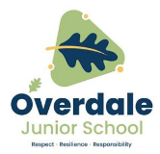

**Year 5 Art – Surrealism. Artist: René Magritte**

**Key Vocabulary and definitions**

**What should I already know?**

* Impressionist Art tries to the effects of

light rather than paint realistic images.

* Pop Art used commercial images and

put them together in unusual ways.

* How to use a colour wheel, including

some opposite (complementary) colours.

• Some knowledge about primary and secondary colours.

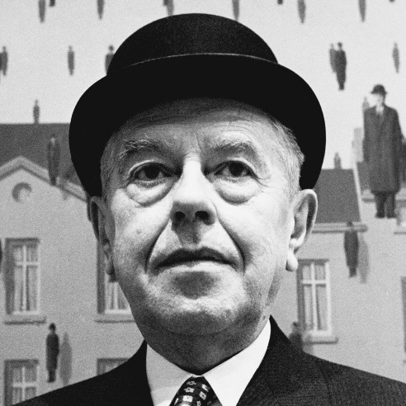

|  |  |
| --- | --- |
| **Surrealism** | A style of painting that put unusual things together to create strange dream-like images. |
| **familiar objects** | Things that you see in ordinary life. |
| **unusual contexts** | Strange ways of putting things together. |
| **position** | Where an object is placed. |
| **scale** | The relative size of objects. |
| **watercolour** | Style of painting using thin watery paint. |
| **acrylic** | Style of painting using thick, bright colours. |
| **tone** | The brightness or darkness of a colour. |
| **mood** | The feeling that an image gives the viewer. |

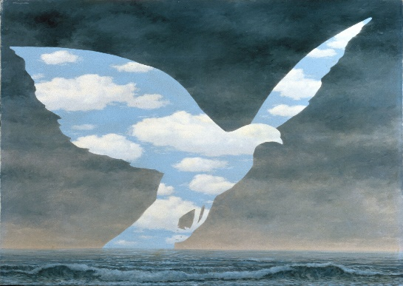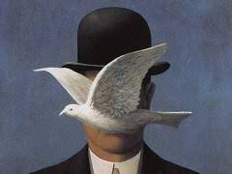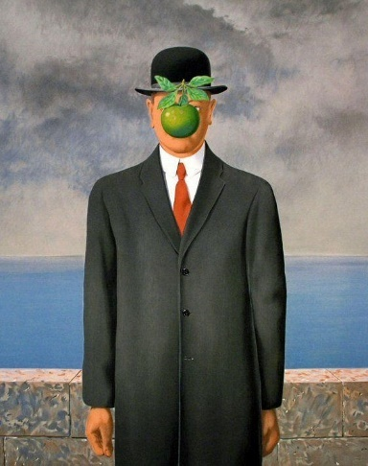 ......

**René Magritte’s colours**

Magritte aften liked to use pale blues, greys and browns

to create images showing sky and land.

|  |  |  |  |
| --- | --- | --- | --- |
|  | pale blue |  | black |
|  |  |  |  |
|  | grey |  | beige |
|  |  |  |  |

**About the artist**

* The surrealist painter René Magritte was

born in Belgium in 1898.

* He worked as a designer in a wallpaper factory and painted images for advertising posters.
* His early paintings were in the Impressionist and Futurist styles.
* He became a Surrealist painter in 1926 and moved to Paris.
* He tried to paint everyday objects in an unusual way to give them a new meaning.
* His early work was criticised and it was only when he was an old man in the 1960s that his work became much more popular.

Son of Man, 1964

The Great Family, 1963

Man in a Bowler Hat, 1964