

**Year 6: Art and Design – Capturing Conflict: *War Art.* Artist/Artisan: *Paul Nash***

**What should I already know?**

* About the Surrealist movement (From Y5 Term 3)
* About the symbolism of light (From my RE lessons)
* About the colour wheel, colour mixing and using water colour.

**Key Vocabulary and definitions**

|  |  |
| --- | --- |
| war art | Art created to document first hand experience of war, produced by artists commissioned by the government. |
| realism | Accurate, detailed representation of nature or life. |
| primary colour | (3) Red, yellow, blue |
| secondary colour | (3) Orange, Green, Violet *(Purple)* |
| tertiary colour | (6) Red-Orange, Yellow-Orange, Yellow-Green, Blue-Green, Blue-Violet, Red-Violet. Formed by mixing a primary with a secondary colour. |
| complimentary colour | Pairs of colours. When placed next to each other, they create a strong contrast. Sometimes called ‘opposite’ colours. |
| mood | The atmosphere in a painting, or the feeling expressed. E.g tranquil, dark, angry, happy. |
| freestyle | The way the paint is manipulated by the brush on the surface. |
| stipple | Apply dots and flicks. |
| blending | Gently intermingling two or more colours to soften lines. |
| natural | Colours taken from nature and the world around us e.g. trees, soil, the sea. |
| a wash | Creating a fine layer of colour over the surface. |
| canvas | Strong, coarse, unbleached cloth used as a material for painting on. |

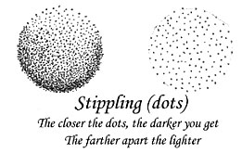 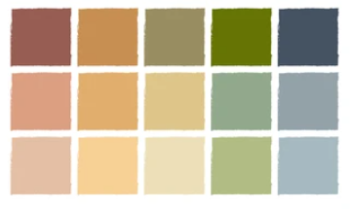 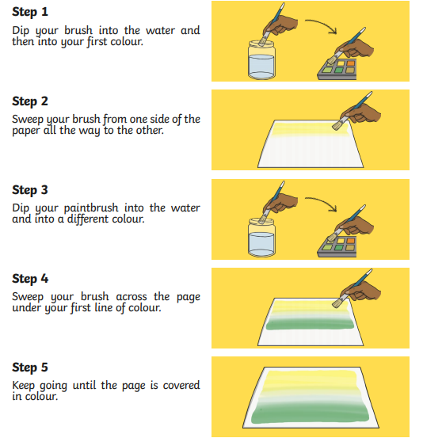

**About the artist**

* 11 May 1889 – 11 July 1946
* A British surrealist painter and war artist.
* Born in London, grew up in Buckinghamshire.
* Developed a love of the landscape – wasn’t very good at drawing people.
* Went to several different art schools
* In September 1914, enlisted in the 2nd Battalion, ‘Artists’ Rifles’.
* Began officer training in August 1916 and was sent to the Western Front in 1917.
* In May 1917, fell in a trench, broke a rib and was invalided back to London where he worked on his war sketches.
* Created 20 pictures which were used in many different exhibitions – they were very popular, so he applied to become an official war artist.
* First official war artist post: Belgium, 1917
* Second official war artist post: England, 1918
* When the war ended, Nash suffered from ‘emotional shock’.

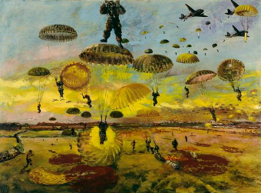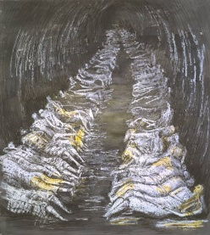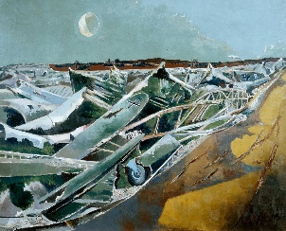

Totes Meer

By Paul Nash

Tube Shelter

By Henry Moore

D-Day

By Albert Richards

Stippling

Natural Tones

Creating a Wash