

**Year 6 Art – Religious (Sacred) Art. Artist - Islamic Art.**

**What should I already know?**

* Religious Art is art made for or about a religion. It can be used to decorate religious items or places of worship.
* Geometric patterns are made by repeating shapes or lines.
* Symmetry means the same on both sides – a mirror image.
* Repetition means the same pattern or shape repeated.

**Key Vocabulary and definitions**

|  |  |
| --- | --- |
| **Islamic Art** | A style of art developed in Islamic countries from the 7th century CE. |
| **geometry** | The mathematics of angles, lines and shapes |
| **tessellation** | Shapes closely fitted together in a repeated pattern without gaps  or overlapping. |
| **calligraphy** | The art of decorative lettering. |
| **arabesque** | A design using flowers, leaves or lines to make a pattern. |
| **ornamentation** | Decoration. |
| **infinite** | Going on forever – having no end. |
| **applique** | Decorative needlework where pieces of fabric are sewn or glued to make a picture or pattern. |

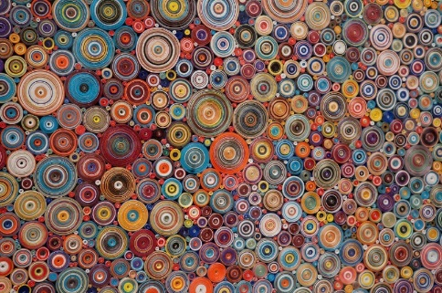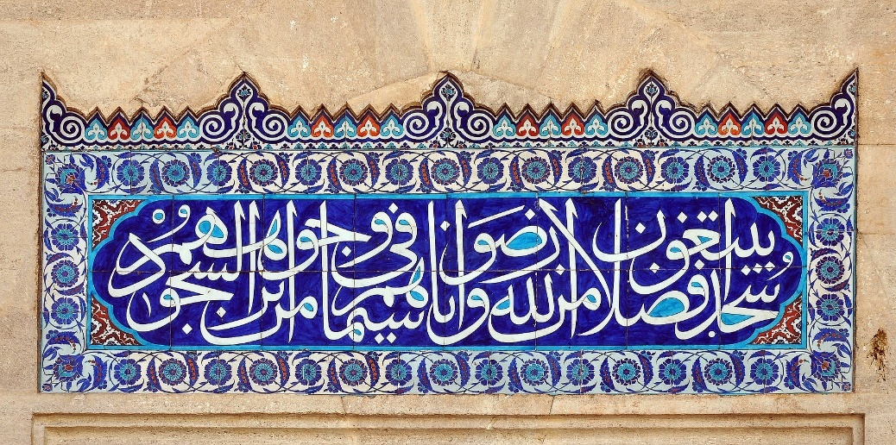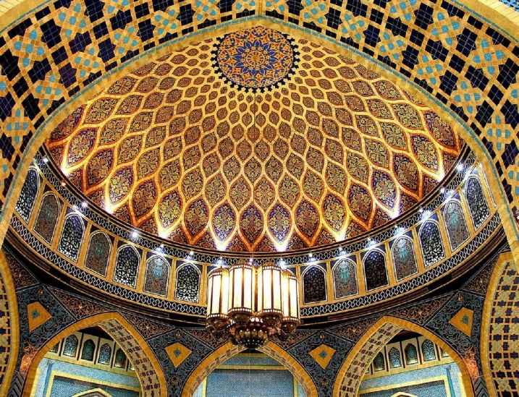.. ......

**Colours in Islamic Art**

Contrasting colours are used in Islamic Art to symbolise visual and spiritual harmony.

|  |  |  |  |
| --- | --- | --- | --- |
|  | white |  | gold |
|  |  |  |  |
|  | pale . . blue |  | dark …red |
|  |  |  |  |
|  | dark *…*blue |  | green |

**About the artists**s

* Islamic Art includes painting, calligraphy, architecture,

textiles and woodwork from more than 40 Muslim nations.

* It is often formed of repeating patterns made up of

geometric shapes, lettering, lines and plant designs.

* It usually does not include images or people or animals.
* Patterns are an expression of Muslim religious beliefs and try to show the infinite and eternal nature of Allah.
* It is often used to decorate buildings, books, clothes, carpets and many other items.
* Some pieces were created hundreds of years ago while others are still being created by contemporary artists today.

painting birds.

* When he was 10 years old he was sent as an apprentice to work for and learn from the famous sculptor Lorenzo Ghiberti.
* He was one of the first artists to use perspective to show landscapes in a realistic and 3D way.
* He was an old man when he painted Saint George and the Dragon in 1470 and gave up painting soon after. He died in 1475.

**The ceiling of the Ibn Battuta Mall in Dubai**

**Calligraphy from the Süleymaniye Mosque in Turkey**