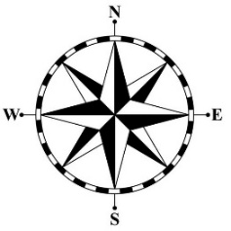

**Grammar**

The same word in English can have more than one word in French. For example, the English word **in.**

**In French we use dans, en or à, depending on the noun that follows it.**

**What should I already know?**

* To state opinions (I like, I love, I dislike)
* To know that il means it
* To know il y a means there is/are
* Months of the year

**Speaking and listening**

Some letters and sounds are pronounced differently to French. That means they sound differently when we speak and hear them.

“en” in French makes the “on”sound.

“au” in French makes the “oh”sound.

l'ouest

le nord

le sud

l’est

**Points cardinaux – compass points**

**Cultural understanding**

Joyeux Noel – Happy Christmas

Père Noël – Father Christmas

**Reading and listening:** I can translate words and phrases when I see or hear them.

**Speaking**: I can say a phrase or short sentence and people can understand me.

**Writing**: I can write words and phrases with most spellings correct.   
I can select words to structure a sentence which makes sense.

**Key Vocabulary**

|  |  |
| --- | --- |
| **Les temps - weather** | |
| il y a du soleil | it is sunny |
| il y a du vents | it is windy |
| il pleut | it’s raining |
| il neige | it’s snowing |
| il fait chaud | it is hot |
| il fait froid | it is cold |

|  |  |
| --- | --- |
| **Les temps – seasons** | |
| au printemps | in the spring |
| en été | in the summer |
| en automne | in the autumn |
| en hiver | in the winter |

|  |  |
| --- | --- |
| **Quand -** when | |
| normalement | normally |
| en général | in general |
| aujourd’hui | today |

**Year 5 French – Weather and Christmas**